Geometry Team Challenge – 6.G.2

Computing Volume Progression 1
a. Amy wants to build a cube with 3 cm sides using 1 cm cubes. How many cubes does she need?
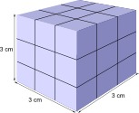
b. How many 1 cm cubes would she need to build a cube with 6 cm sides?

Computing Volume Progression 2
- Amy has a fish tank shaped like a rectangular prism that is 20 cm by 20 cm by 16 cm. What is the volume of the tank?
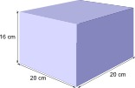
- If Amy only fills the tank 3/4 of the way, what will be the volume of the water in the tank?

Computing Volume Progression 3
A rectangular tank is 50 cm wide and 60 cm long. It can hold up to 126 ℓ of water when full. If Amy fills 2/3 of the tank as shown, find the height of the water in centimeters. (Recall that 1 ℓ=1000 cm3.)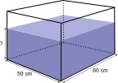

Computing Volume Progression 4
A rectangular tank is 24 cm wide, and 30 cm long. It contains a stone and is filled with water to a height of 8 cm. When Amy pulls the stone out of the tank, the height of the water drops to 6 cm. Find the volume of the stone.
