Name:____________________ Period:_____ Date:_________

Perimeter and Area in the Coordinate Plane Review

For each problem:
- Plot the ordered pairs in the coordinate plane given
- Find the perimeter of the figure
- Find the area of the figure

- R (0, 5) S (5, 0) T (-5, 0)

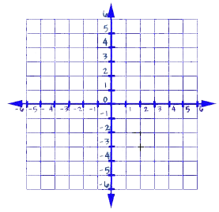

Perimeter of RST:__________ Area of RST:_________

- G (-2, 3) H (3, 3) I (-4, -2) J (1, -2)

Perimeter of GHIJ:__________ Area of GHIJ:_________

- This figure is a four sided polygon. Before finding the area and perimeter find the missing point.

M (-3, 3) N (5, 3) O ( , ) P ( -3, -4)

Perimeter of MNOP:__________ Area of MNOP:_________

What was the fourth vertex?

How did you find the length for each side of the figure?

- On a map, the library is located at (-6, 6), the city hall building is located at (4,6), and the high school is located at (4,4).

Represent the locations as points on a coordinate grid with a unit of 1 mile.

- What is the distance from the library to the city hall building? The distance from the city hall building to the high school? How do you know?

- What shape does connecting the three locations form? The city council is planning to place a city park in this area. How large is the area of the planned park?

