Geometry Team Challenge – G.1

Base and Height
Mrs. Lito asked her students to label a base b and its corresponding height h in the triangle shown.
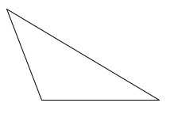
Three students drew the figures below.
- Raul
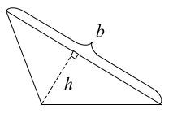
- Mark
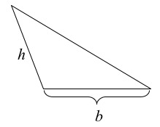
- Kiki
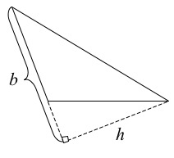
- Which students, if any, have correctly identified a base and its corresponding height? Which ones have not? Explain what is incorrect.
- There are three possible base-height pairs for this triangle. Sketch all three.
Finding Areas of Polygons
Find the area that is shaded in each figure in at least two different ways.
- 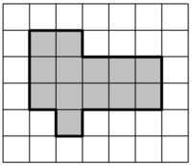
- 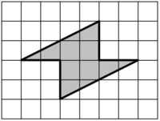
- 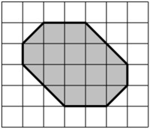
- 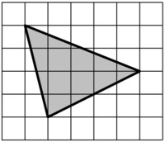

Same Base and Height, Variation 1
Make the following triangles on a geoboard. Remember that the pegs are equally spaced in a square grid. Compare the areas of the triangles.
- Which has the greatest area?
- Which has the least area?
- Do any of the triangles have the same area?
- Are some areas impossible to compare?
Explain why you answered as you did.
