Name ______________
Date _______________
Ratios and Proportions (RP.3b)
1. The photograph below is enlarged to make a poster.// 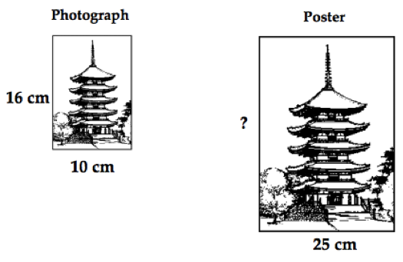
(a) How tall is the poster?
(b) The building on the poster is 30cm tall.
Is it possible to figure out how tall the building is on the photograph?
If you think it is possible, show how. If you think it is not, explain why.

2. Here is a recipe for making 4 pancakes:
$•$ 6 tablespoons flour
$•$ $\frac{1}{4}$ pint milk
$•$ $\frac{1}{4}$ pint water
$•$ 1 pinch salt
$•$ 1 egg
You want to make 10 pancakes.
(a) How much flour do you need?
(b) How much milk do you need?

3. Calculate the prices of the paint cans.
The prices are proportional to the amount of paint in the can.
