Ratios (RP.3c) Name ________________________
1. What percent is represented below?
2. Represent 86$\%$ on the grid below.
3. In June 2012, Selena Gomez surveyed 900 Americans and found that 430 approved of President Obama’s policies. What was Obama’s percentage approval rating?

4. For a-d, refer to the table below.
a. How many crimes were perpetrated in the US in 1995?
b. What percentage of the total crimes were violent crimes?
c. What percentage of the Property Crime in Metropolitan Areas was Motor Vehicle Theft?
d. Write a complete sentence that fully describes what the number 234, found in the Violent Crime Row, means. Write the sentence in the style of a newspaper article.
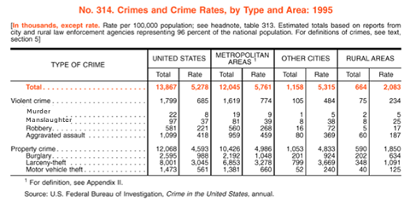
5. Which is greater, 73 percent of 87, or 87 percent of 73?
6. What is 84$\%$ of 86?
7. How many squares would represent 1089 cars?
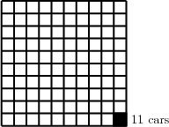
8. How many people are represented by 50 squares? 25? 10? 1?
9. Last week, Rihanna bought a DVD for $10.80 while the store was having a 25$\%$ off sale. The sale is now over. How much would the same DVD cost today?

10. 116 is 177$\%$ of what number?

11. In 2000, Cincinnati, OH set two population goals:
a. Increase the city’s overall population
b. Increase the population of downtown Cincinnati. According to the table below, did the city meet its goals?
