Statistics (6.SP.2)
1. Macklemore is a basketball scout for the University of Connecticut who has collected data on the points per game for two high school players, yielding the distributions below.
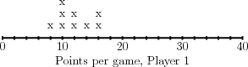
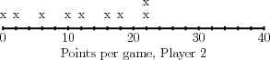
Macklemore decides to start by comparing the centers of the distributions.
(a) What are the mean and median of each distribution?
(b) What do the mean and median not reveal about the distributions?
(c) Which player do you think Macklemore should recruit? Explain.

2. Adrian Peterson is a video game designer. He recently gathered some information on the number of hours that people play his game each week.
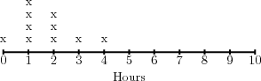
(a) What is the mean of the distribution? The median?
(b) What is the mean absolute deviation? The interquartile range?
(c) How would you describe the shape of the data?

