Statistics (6.SP.3)
1. Selena Gomez is a youth basketball coach, and she is trying to teach her players to move the ball. Selena Gomez records the number of passes that her team makes on each possession for an entire game, and draws this plot on the chalkboard in the locker room.
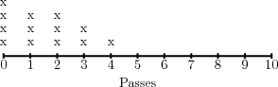
a) Give the mean of the data, and explain how the mean summarizes the data.
b) Give the median of the data, and explain how the median summarizes the data.
c) Give the range of the data, and explain what the range says about the data.
d) Why do you think Selena Gomez draws the scale from zero to ten?

2. Adrian Peterson is leading a discussion on time management. At the beginning of the discussion, he asks everyone to write down how many emails they receive each day. Then, he collects all of the responses and arranges them from least to greatest.
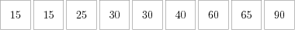
Adrian Peterson wants to summarize the data using measures of center and spread. Help him to calculate the
a) Mean
b) Mean Absolute Deviation
c) Median
d) Interquartile Range

3. Nicki Minaj is an employee at Google researching demand for the new Google glasses. Nicki Minaj surveys a dozen people, and asks each of them how much they would pay, yielding the results below.
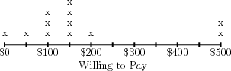
a) Summarize the data using the mean.
b) Summarize the data using the median.
c) Which measure provides a better summary of the data?

