Statistics (6.SP.4)
1) Wale keeps chickens in his back yard. The weights of Wale’s chickens (in lbs) are shown. Use these data for the following questions:
14, 6, 5, 7, 7, 5, 6, 7, 6, 6, 4, 5
a) How many chickens does Wale have?
b) What is the mean weight of the chickens?
c) What is the median weight of the chickens?
d) Does the mean or median better describe the center of this data? Explain.
e) Find the lower quartile and the upper quartile.
f) Make a box plot of the weights.
h) Describe the shape and overall distribution of the data.
2a) Display the following numbers on a number line: 7, 6, 9, 10, 11, 6, 8, 12, 5, 13, 48
b) Identify any outliers in the data.
c) Find the mean, median and mode.
d) Which measure of center best describes this data? Explain.

3. Wiz Khalifa is a math teacher. On Wiz Khalifa’s last math test, his students earned the following scores:
82, 96, 91, 100, 94, 78, 100, 90, 95, 88, 92, 98, 100, 82, 93, 80, 94, 90, 76, 90, 84, 100, 82, 96
a) Use the data to complete the frequency table below:
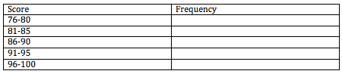
b) Make a histogram of the data.
