Statistics (SP.5d) – Team Challenge

Electoral College

Unlike many elections for public office where a person is elected strictly based on the results of a popular vote (i.e., the candidate who earns the most votes in the election wins), in the United States, the election for President of the United States is determined by a process called the Electoral College. According to the National Archives, the process was established in the United States Constitution "as a compromise between election of the President by a vote in Congress and election of the President by a popular vote of qualified citizens." (http://www.archives.gov/federal-register/electoral-college/about.html accessed September 4, 2012).
Each state receives an allocation of electoral votes in the process, and this allocation is determined by the number of members in the state's delegation to the US Congress. This number is the sum of the number of US Senators that represent the state (always 2, per the Constitution) and the number of Representatives that represent the state in the US House of Representatives (a number that is directly related to the state's population of qualified citizens as determined by the US Census). Therefore the larger a state's population of qualified citizens, the more electoral votes it has. Note: the District of Columbia (which is not a state) is granted 3 electoral votes in the process through the 23rd Amendment to the Constitution.
The following table shows the allocation of electoral votes for each state and the District of Columbia for the 2012, 2016, and 2020 presidential elections. (http://www.archives.gov/federal-register/electoral-college/allocation.htmlaccessed September 4, 2012).
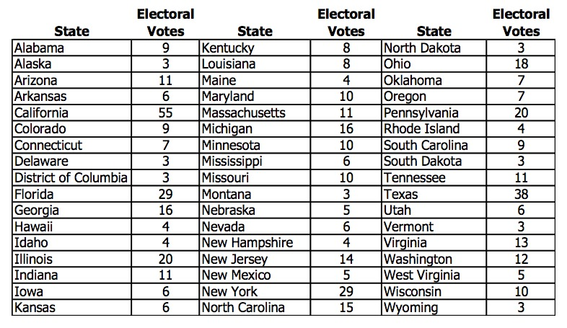
- Which state has the most electoral votes? How many votes does it have?

- Based on the given information, which state has the second highest population of qualified citizens?
- Here is a dotplot of the distribution.
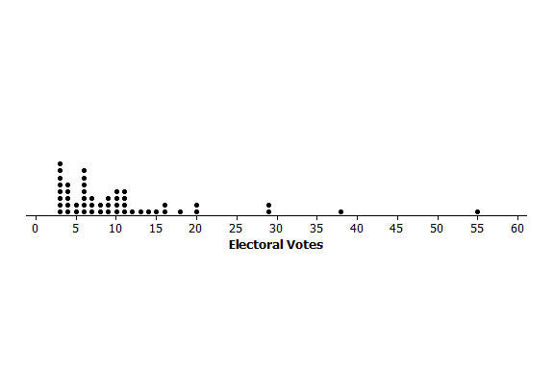
  - What is the shape of this distribution: skewed left, symmetric, or skewed right?

  - Imagine that someone you are speaking with is unfamiliar with these shape terms. Describe clearly and in the context of this data set what the shape description you have chosen means in terms of the distribution.

- Does the dotplot lead you to think that any states are outliers in terms of their number of electoral votes? Explain your reasoning, and if you do believe that there are outlier values, identify the corresponding states.

- What measure of center (mean or median) would you recommend for describing this data set? Why did you choose this measure?

- Determine the value of the median for this data set (electoral votes).

