EE.4 - Team Challenge

Equivalent Expressions

Which of the following expressions are equivalent? Why? If an expression has no match, write 2 equivalent expressions to match it.
2(x+4)

8+2x

2x+4

3(x+4) − (4+x)

x+4

Rectangle Perimeter 2
The students in Mr. Nolan's class are writing expressions for the perimeter of a rectangle of side length ℓ and width w. After they share their answers, the following expressions are on the board:

Sam: 2(ℓ+w)
Joanna: ℓ+w+ℓ+w
Kiyo: 2ℓ+w
Erica: 2w+2ℓ
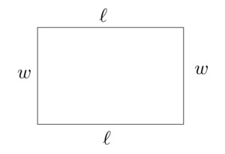
Which of the expressions are correct and how might the students have been thinking about finding the perimeter of the rectangle?

