Name ______________
Date _______________
Geometry (G.4)
1. Mr. Vance is making a simple bedside stand for his son. The stand is a right rectangular prism with the dimensions of the figure below. Mr. Vance needs to find the surface area of the stand to figure out how much paint to buy. What is the surface area of the stand?
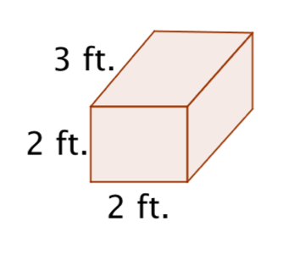

2. The figure below is a square pyramid. Create a net and use the net to find the surface area of the pyramid.
