Statistics (SP.5c)
1. The National Air and Space Museum is creating an exhibit in honor of the Space Shuttle program, and you have been asked to summarize some key information about the solar system.
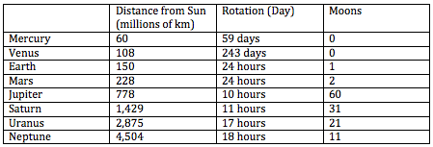
a) Your first responsibility is to display each of the data sets using a dot plot or box plot so that museum visitors can quickly understand the distributions.
b) What is the overall shape of each distribution?
c) Find the median and IQR of each distribution.

